**Topic : Conflict resolution: Address challenges related to conflict resolution during data synchronization, such as handling conflicting updates or changes made to the same data by multiple users or systems**

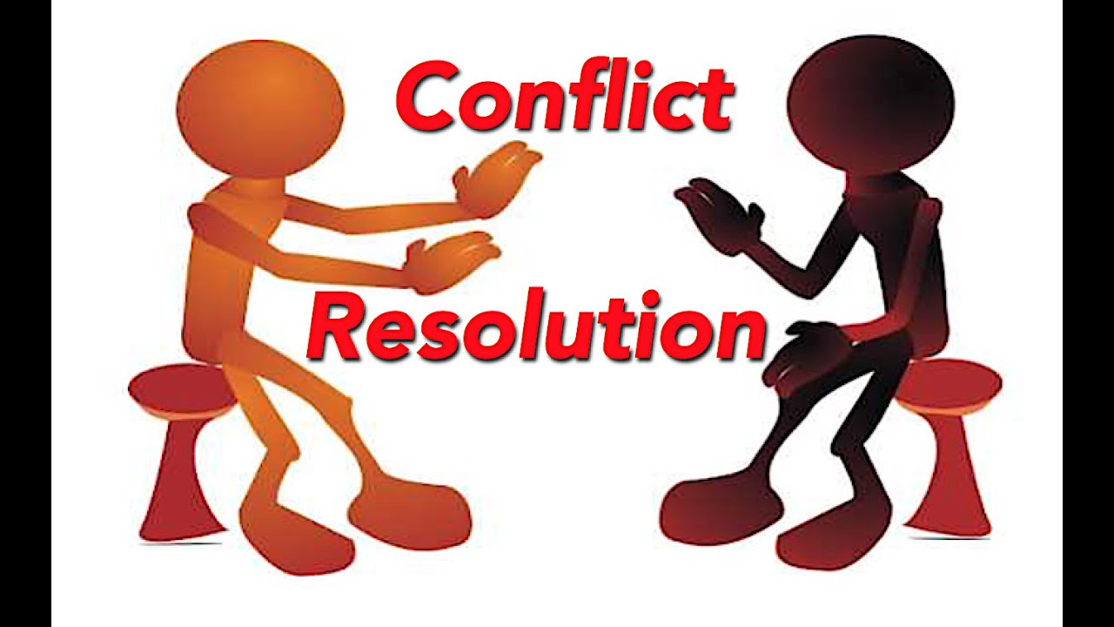

**Conflict resolution is a crucial aspect of data synchronization, ensuring that data consistency and integrity are maintained even when multiple users or systems make conflicting changes. Let's dive into the challenges and some virtual explanations!**

**Challenges:**

**1. Conflicting updates: When multiple users update the same data simultaneously, conflicts arise.**

**2. Data inconsistency: Changes made by one user may overwrite another user's changes, leading to data loss or corruption.**

**3. Version control: Managing different versions of data to ensure the most up-to-date version is used.**

**Virtual Explanation:**

**Imagine a collaborative document editing scenario:**

**User 1 and User 2 are editing a shared document simultaneously. User 1 changes a sentence, while User 2 changes the same sentence differently. When they try to save their changes, a conflict arises.**

**To resolve this conflict, a conflict resolution strategy is employed:**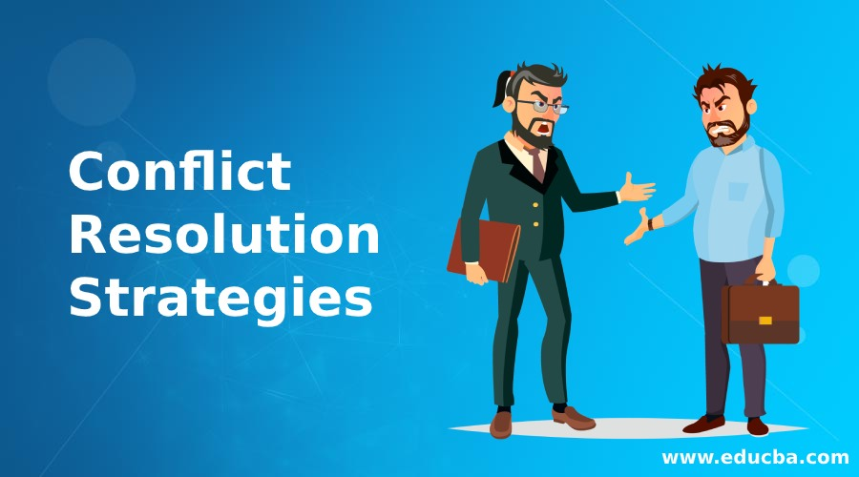

**1. Last writer wins: The last user to save their changes wins, and their version becomes the latest.**

**2. First writer wins: The first user to save their changes wins, and their version becomes the latest.**

**3. Manual resolution: A moderator reviews both versions and manually resolves the conflict.**

**4. Version control: The system tracks changes and creates a new version, allowing users to merge or revert changes.**

**Other conflict resolution strategies include:**

**- Two-phase commit: A temporary storage area holds changes until conflicts are resolved.**

**- Operational transformation: Changes are transformed to ensure consistency, like in real-time collaboration tools.**

**- Multi-version concurrency control: Multiple versions are stored, allowing for easy reverts and merges.**

**By implementing these strategies, data synchronization systems can effectively resolve conflicts, ensuring data consistency and integrity in collaborative environments.**

**Virtual Explanation In Image form:**

**Here are some simple graphics to illustrate the conflict resolution strategies I mentioned earlier:**

**Last Writer Wins**

**User 1 and User 2 edit a shared document**

**+---------------+**

**| Original |**

**+---------------+**

**|**

**| User 1 edits**

**v (Version 1)**

**+---------------+**

**| User 1's |**

**| changes |**

**+---------------+**

**|**

**| User 2 edits**

**v (Version 2)**

**+---------------+**

**| User 2's |**

**| changes |**

**+---------------+**

**|**

**| Last writer wins**

**v (Version 2 prevails)**

**+---------------+**

**| Final version|**

**+---------------+**

**First Writer Wins**

**User 1 and User 2 edit a shared document**

**+---------------+**

**| Original |**

**+---------------+**

**|**

**| User 1 edits**

**v (Version 1)**

**+---------------+**

**| User 1's |**

**| changes |**

**+---------------+**

**|**

**| First writer wins**

**v (Version 1 prevails)**

**+---------------+**

**| Final version|**

**+---------------+**

**|**

**| User 2 edits (ignored)**

**v**

**Manual Resolution**

**User 1 and User 2 edit a shared document**

**+---------------+**

**| Original |**

**+---------------+**

**|**

**| User 1 edits**

**v (Version 1)**

**+---------------+**

**| User 1's |**

**| changes |**

**+---------------+**

**|**

**| User 2 edits**

**v (Version 2)**

**+---------------+**

**| Conflict! |**

**| Manual resolution|**

**+---------------+**

**|**

**| Moderator reviews**

**v (Resolves conflict)**

**+---------------+**

**| Final version|**

**+---------------+**

**Version Control**

**User 1 and User 2 edit a shared document**

**+---------------+**

**| Original |**

**+---------------+**

**|**

**| User 1 edits**

**v (Version 1)**

**+---------------+**

**| Version 1 |**

**+---------------+**

**|**

**| User 2 edits**

**v (Version 2)**

**+---------------+**

**| Version 2 |**

**+---------------+**

**|**

**| Version control**

**v (Merges changes)**

**+---------------+**

**| Final version|**

**+---------------+**

**These graphics illustrate the different conflict resolution strategies, showing how each approach handles conflicting changes. Let me know if you have any further questions or need more clarification!**

## **What Is Conflict Resolution in Workshop?**

**Conflict resolution is a process that helps people resolve disagreements peacefully and effectively.**

